running the command to prove that you can read the results on the command line
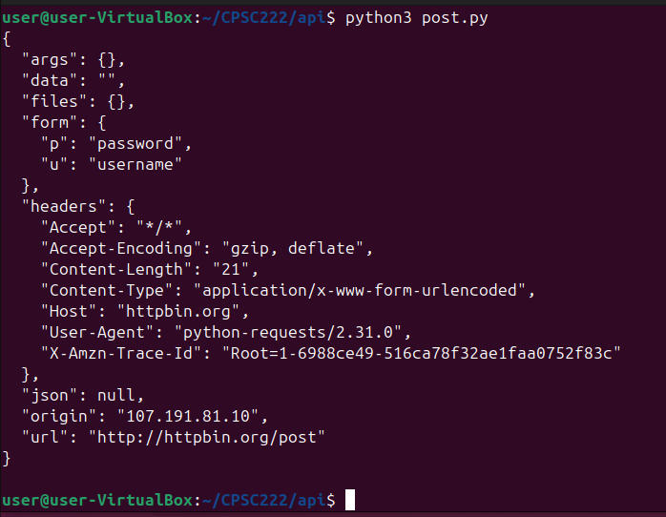
running git config --list
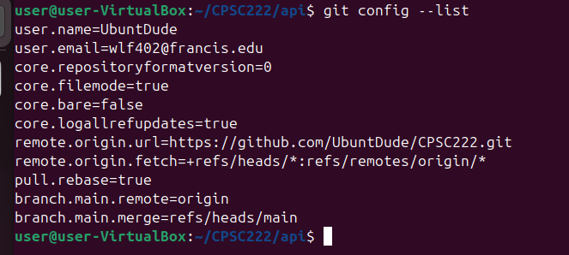
running pwd and ls -la from your repo directory that contains the above files
